**Integrated Human Practices**

**1 Discover**

**The birth of SLIM**

**开头要写主题句(概括两件事，然后对接 one health 主线，for health for earning 分支)**

It was a casual conversation with a rural relative of one of our team members. It was a casual glimpse of a piece of news about lead poisoning.（two incidents sowed the seed of ）, the seed of SLIM was sowed, and it was born in this world quietly.

****

**Peasant Wang Ping （）**

We called Wang Ping. He said it was common to apply pesticides and fertilizers in his village. He found that there were indeed fewer earthworms in the soil than before. (逻辑推理顺序引出设想)The soil looks unhealthy and is inclined to agglomerate.

Although the vegetables seem to grow faster, there’s a high risk for vegetables to be attacked by pests and bacteria, causing a huge loss for Wang Ping.

Pesticides and fertilizers contain lots of heavy metals. （原因：恶性循环购买金钱和蔬菜卖不好）

We assume there were some relations between heavy metals, earthworms and soil. This little assumption inspired us to use earthworms to improve the heavy metal contaminated farmlands. We do really want to help peasants, like Wang Ping, reduce the economic loss.

****

**Children suffering from lead poisoning**

We felt shocked at a glimpse of a piece of news, *Children suffering from lead poisoning* in Chenzhou is rising sharply. A village in Chenzhou, Hunan province was polluted heavily by lead a few years ago. Chenzhou was famous for its lead-zinc deposit and large quantities of leads were detected in the farmlands. Most villagers made a living by farming, so they were exposed to soil, crops, water and even air with leads every day.

That means what they ate, drunk and even breathed in has been severely polluted. There were only 23,000 children, but over half of them were found to have excessive levels of lead in their blood. They had symptoms like weakened immune systems, slow growth and lack of concentration.

Although it’s been 10 years and the environment has been improved, the soil is still in pollution. This incident has drawn our great attention, and we want to help them through synthetic biology. （环境问题结合合成生物学方法，保护人类健康）

**What did we want to do?（人、动物、环境相互作用，寻找一种相互有益的方法，合成生物学的方法促进融洽相处）**

When children's health is at risk, when farmers' income is lost, when food safety is under threat，we hope one day, lead poisoning will be away from children, the income of peasants will be protected, and the food safety crisis will not appear.

不是表达愿望，而是我们要做什么

**2 Understand**

**（困惑关系，了解one health 系统，与one health联系在一起，咨询采访）**

**Communication with One health**

By chance we knew One Health, introduced by our group members, drawing our attention. After a coffee hour with One Healthers, we got a better understanding of our world and our project.

**One Health** is a collaborative, multisectoral, and transdisciplinary approach—working at the local, regional, national, and global levels—with the goal of achieving optimal health outcomes recognizing the interconnection between people, animals, plants, and their shared environment.

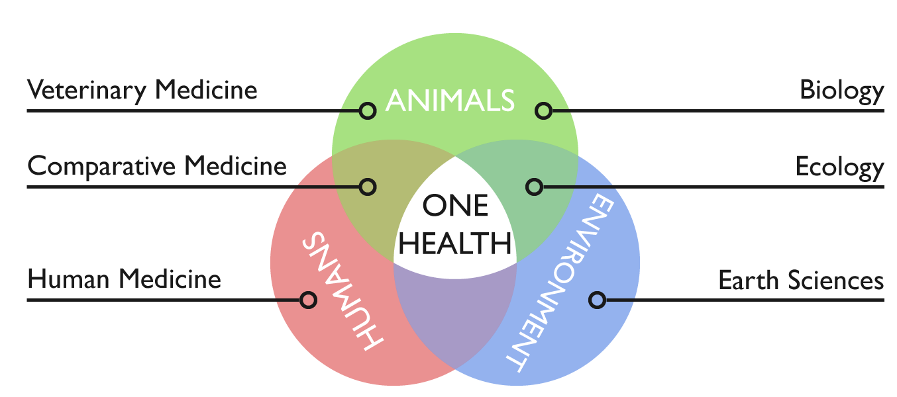

图的来源是什么？自己画的？引用的？需要注明

**One Health Club NAU,** a club organized by students, is building the NAU-UCDavis One Health Joint Center with UCDavis. With environmental degradation, the boundary between human society and nature is going to be indistinct, causing a threat to human health. To solve the problem, One Health was born, holding a promise to attain optimal health for **people, animals and environment** with the **effort of multiple disciplines**.

We talked with Dr. Osburn, Christie and One Healthers in Lunch Time Challenge to share the story of SLIM, where we knew how to explore the communities, institutions, or individuals affected by the problems. Most important of all is that we got kind suggestions and help from Dr. Osburn and Christie, which helped to shape SLIM better.

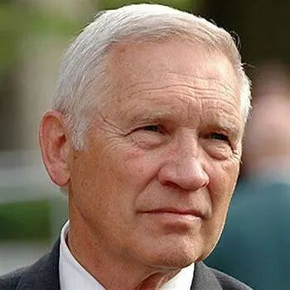

**Dr. Bennie I. Osburn**

Dr Osburn is Dean Emeritus, School of Veterinary Medicine, UC Davis and the director of Outreach and Training in Western Institute for Food Safety & Security. WIFSS is a University of California, Davis program of the School of Veterinary Medicine and the College of Agricultural and Environmental Sciences. In order to facilitate a better understanding of the complex interactions of humans, animals and the environment, multidisciplinary centers, institutes and programs, including WIFSS, were organized and developed during his tenure as dean.

We talked with him in LTC. He said, “Yes, One Health is the integrative effort of multiple disciplines working locally, nationally, and globally to attain optimal health for people, animals, and the environment. I’m glad that you can utilize a One Health approach in your project. In my views, what people care about most is their health and freedom from disease. We often fail to consider the environments role with health problems affecting people, plants and animals. The topic your team has selected to study, lead toxicity, is an excellent example of an environmental problem affecting human health. Young children are often affected with lead poisoning because of contaminated, air, water or foods. Lead toxicity can affect neurological and cognitive development. There is a need for creative thinking of ways to mitigate the toxic effects of lead that is in the environment, so finding new ways of detoxifying the chemical or partitioning it out of the food or water supply is also attractive.

These discussions are helpful for both the faculty and clinical programs with clients. What we do can contribute to the protection of food safety, and we can demonstrate our works by utilizing a One Health approach. So, we plan to consult experts in the health of humans (especially in blood lead), animals and environment.

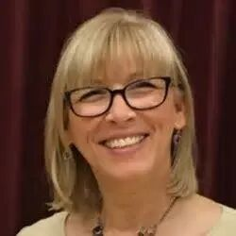

**Christie Marie Brunner**

Chris Brunner, as a communications and international programs director in WIFSS, devotes herself in education of One Health. She always holds an open mind to take in novel ideas and are kind enough to share relevant information with us, which help us a lot.

We emailed her and talked with her in LTC. She said, “I am thrilled to know young adults such as yourself are addressing soil health and food safety through the comprehensive One Health approach. You and I know that One Health helps us by understanding that lead is naturally in the earth’s crust and once it is mined and processed it does not break down, instead it again covers the air and landscape where it is picked up by plants, animals and people.   Once it enters animals and people it causes illness and even death.  For this reason, it is important that we attempt to find ways to prevent plant, animal and human illnesses.  We care about the health of the soil as it relates to the health of ALL living things.  One Health is a difficult thing to translate to a farmer who is concerned about meeting financial obligations. When you can demonstrate that having healthy soil will allow him or her to grow more crops and make more money and provide healthy food for his or her family, and the community, the light bulb goes off and it becomes easier to make the connection between the health of the soil and the health of people.”

Chris still emphasized the importance of teamwork and collaboration. So, we spread the good word about One Health in cooperation with other iGEM teams and are determined to make a brochure to help people understand we are all connected, from the soil to the table, and that goes for everything in between: plants, animals, water, air.

Besides, she recommended Dr. Jorge L. Mazza Rodrigues to us and shared some research papers with us like [Remediation of heavy metal contaminated soil by asymmetrical alternating current electrochemistry](https://www.nature.com/articles/s41467-019-10472-x" \t "_blank) , which always inspired us.

**Key stakeholders and experts interview**

**(1)Human Health**

**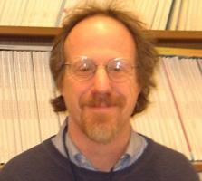**

**Dr. Joseph Bressler**

Dr. Joseph Bressler is an expert in environmental health and blood lead of The Johns Hopkins University.

Why did we want to ask him?

how it affects children

any effective treatment.

Since Lead does harm to children severely, we wanted to know how it affects children and whether there is any effective treatment.

What did we know?(bullets:概括)

He shared the mechanism of lead poisoning where we knew **it’s difficult to cure and the best treatment is to prevent.** He said, “In children, the toxicokinetic of lead include absorption through the intestine via iron and calcium transporters, transfer to the blood (99% in rbc and 1% in serum), distribution to soft tissues (e.g. brain and kidney), and storage in the bone.  The bone lead remains throughout one’s life and might re-enter the blood when there is bone loss during aging. There is a strong relationship between blood and impaired cognitive development at all blood lead levels. There is no blood level thought to be safe.  This is very different from other contaminants that do not increase the risk of cancer.”

He also said the rate of lead poisoning in America has declined sharply. Polluted soil is not often to see in America. However, old water pipes remain the most important problem. When water is treated with chlorine, the acidity increases leaching of the lead from the pipe, the water companies are obligated to test and adds a chemical (phosphate) to insolubilize the lead thereby preventing lead from entering the water supply. This is what happened in Flint, MI but the water company did not add phosphate. **So your idea to produce phosphate is right.**

**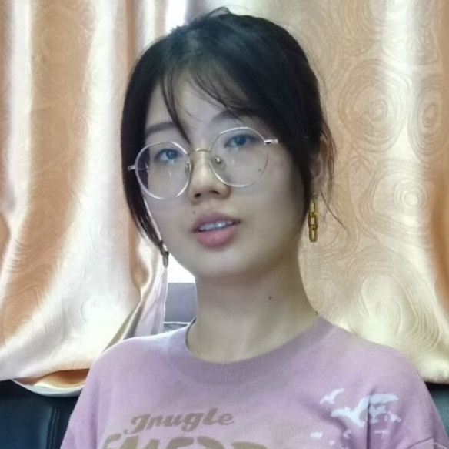**

**Inspector Xu Ningyue**

**Xu Ningyue is an inspector of agricultural products from The Committee on Agriculture**

Why did we want to ask her?

The lead in soil can accumulate in vegetables, then which are eaten by us？So food safety is important to human health. To know more about that, we wanted to ask her.

What did we know?

Ms. Xu said that in her daily work, it’s common to find problems of excessive heavy metals in agricultural products, such as cadmium in paddy and lead in vegetables. The sources of heavy metals are very extensive, like industrial pollution, pesticide residues and automobile exhaust. The pollution can be divided into two parts-- exogenous pollution and endogenous pollution. The former like pesticide residues and bacteria can be easily eliminated through common wash and cooking, but the latter not. So, the only way to prevent it is to stop the gathering in vegetables. That is to solve the environmental problem.

In China, **12 million tons** of vegetables and crops are polluted by heavy metals every year, causing an economical loss of **20 billion yuan**. **The biggest losers are peasants.**

Besides, Ms. Xu advised us to get more information from the policy released by governments, **Control of Soil Risk Management in Agricultural Land**, from which we knew heavy metals pollution is widespread in China.

**(2) Environmental Health**

**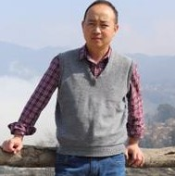**

**Professor Guo Xianhua**

Professor Guo Xianhua is an expert in heavy metal pollution treatment from Chongqing Three Gorges University.

Why did we want to ask him?

We wanted to know the situation lead contamination situation in China, and make sure our application-background and the advantages of our project.

What did we know?

According to the census shared by Professor Guo, polluted areas often come from places near lead-zinc deposits, like southwest and middle-of-south in China.

In addition，He shared merits and demerits of lots of methods nowadays (shown in Table 1) with us and were kind enough to give us data of soil in Yunnan.

Table 1

|  |  |  |  |
| --- | --- | --- | --- |
| Methods | Applied Range | Cost | Risk |
| Plant processing | Heavy pollution  Large area | Relative low cost | Be easy to cause second pollution |
| Soil amendments | Short-term emergency | -- | Resorption of pollutants |
| Physical methods | Small area | High cost | -- |

****

**Professor Li Zhen**

Professor Li Zhen is an expert in soil microorganism from Nanjing Agricultural University.

Why did we want to ask him?

We wanted to know feasibility of our project and the relations between earthworms and microorganism.

What did we know?

Professor Li said，“Many phosphate-solubilizing microorganisms have a strong tolerance to lead and are largely unaffected. Organic binding states or other forms of heavy metals may affect the final formation of insoluble, but not seriously. Pyromorphite is almost the most stable lead bearing mineral. ”Besides，Professor Li solved the problems of soil environment and lead fixation by phosphorous microorganism, which played a great role in the experimental progress in the our team .

1. **Health of Animals**

**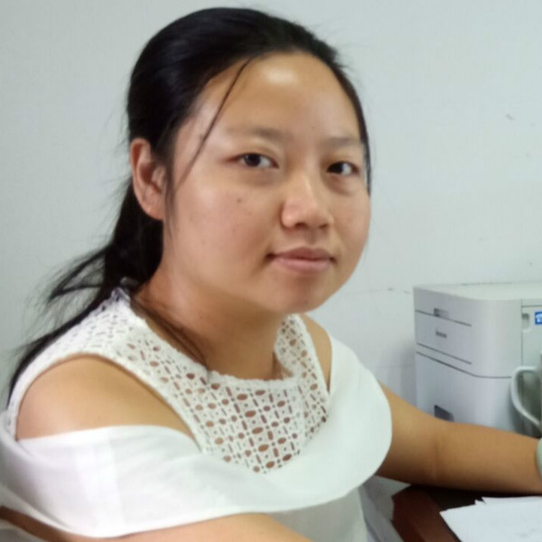**

**Researcher Zhou Peixiang**

Zhou Peixiang is a researcher in management of excrements pollution of livestock and feed safety from Animal Health and Safety Center

Why did we want to ask her?

From the conversations with Dr. Osburn, we’ve known it harms animals. So we wanted to know how do it affect animals.

What did we know?

Ms. Zhou was fascinated with our idea. She said, “In fact, there are plants using earthworms to remove the heavy metals in excrements of livestock and poultry. The excrements contain heavy metals, and earthworms are tolerant to it. Moreover, feed is sometimes found to have heavy metals problem. This has a huge impact on animal productivity, causing a considerable economic loss to stock-breeding. It can also affect human health through the food chain.”

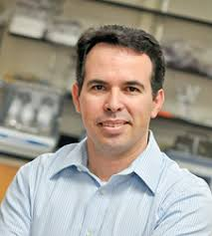

**Dr. Jorge L. Mazza Rodrigues**

Jorge, a professor in the Department of Land, Air and Water Resources, specializes in soil microbiology. His research interests are microbial ecology, tropical forests, land use change, biodiversity, metagenomics, metaproteomic, ecological genomics, lignocellulose conversion, microbial physiology.

 Why did we want to ask him?

We emailed him and talked with him in LTC. Dr. Jorge said, “There are many benefits of microorganisms interacting with plants: microbes help with biocontrol of other microorganisms, promote nitrogen fixation, provide growth through hormones, allow for nutrients to be recycled and stabilize soil preventing erosion.”

 What did we know?

After reading his paper Amazon forest-to-agriculture conversion alters rhizosphere microbiome composition while functions are kept, we started to think about the influence of engineering bacteria to microbial biodiversity. We also raised questions “What’s the relation between earthworms and Bacillus subtilis” and “Are engineering Bacillus subtilis safe for earthworms”. Bacillus subtilis is the intestinal beneficial bacteria in earthworms, and they’re like good friends. Engineering Bacillus subtilis just produce enzymes that can promote the tolerance of earthworms in lead contaminated soil. That’s safe for them.

1. **Agricultural economics**

**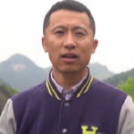**

**Government Official Pei Haiyan**

Pei Haiyan is a government official and devotes himself in agricultural economy.

Why did we want to ask him?

We wanted to know how can we promote agricultural economy by our project and how to help farmers and peasants.

What did we know?

We attended a lecture, and raised some questions to him. He showed great confidence to the development of organic agriculture and our project. He said peasants can get a lot by developing organic agriculture. If we can ensure the consumers pollution-free vegetables, there will be more consumers choosing these and more money that peasants can get.

Moreover, he suggested us to investigate consumers' willingness to buy pollution-free vegetables and the concerns about it.

**3 Create （保障人类健康，衍生经济）**

**One Health**

How do we integrate a one health approach into SLIM?

1. Consultations with stakeholders and experts in the thought of one health (which has been shown in Discover part);

2. Utilize the power of teamwork, reaching out to other teams for collaboration, that’s what we’ve learned from One Healthers and also a main part of iGEM;

3. Interview stakeholders from the soil to the table, and that goes for everything in between: plants, animals, water, air.

**For Health and For Peasants**

What is For Health and For Peasants?

For Health and For Peasants is a scheme to let consumers get healthier food and help peasants get more earning by conducting and interviewing in every stage. In the “sphere of interest”, government officials encourage contractors to buy SLIM earthworms, and peasants work for them. Then, green food will be produced, that more and more consumers will choose for their health. More people choose SLIM green vegetables, more money peasants can get.

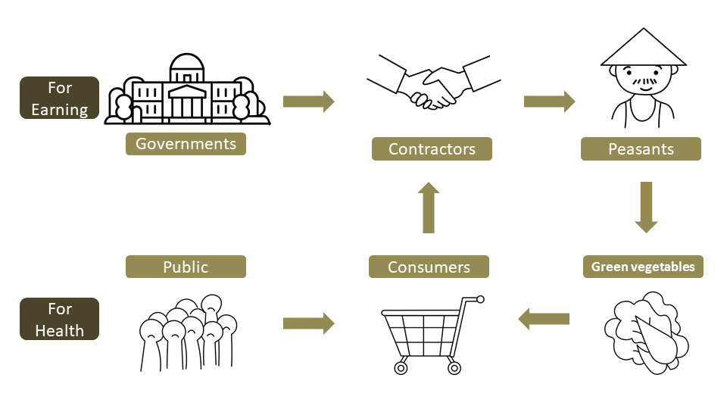

**（改）**

**4 Implement**

To understand if our scheme consistent with the actual situation, so we interviewed key stakeholders in every stage.



A government official

Why did we want to interview him?

We wonder if governments could help us to encourage enterprises to buy our SLIM earthworms and promote the promote cooperation between enterprises and peasants.

What did we get?

A government official said, “In fact, we’ve done lots of work on agricultural economic. There’s already been some policise associated with the protection of farmlands. To expand economic and solve the poverty problem, the govenments encourage cooperation between enterprises and peasants and help them to sale more products, with the help of e-ecommerce and live. If you want us to help promote cooperation, your project must be approved by the relevant departments to ensure safety and effectiveness. “

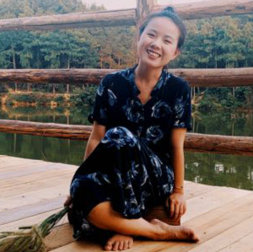

An [enterprise](https://www.baidu.com/link?url=Q1wwttz9QD-fQVl7Vip6Iylbd4adFHpaYg7nFJyH7JYl6kLQuPjO7VGGXfTwuz0Ue4l4faN2_pYCuc_NKJZcvcEb8nPZh0NIsLKkLNr3R93&wd=&eqid=ad7531a00023ae92000000045f3fce91)

Why did we want to interview her?

We wonder if enterprisers could adopt our project to recover unhealthy earth and how much benefits peasants can get from enterprises.

What did we get?

We interviewed Xiao Yuan, an agricultural enterpriser. She said, “We use a mode of “peasants + cooperation+ family farm”. In China, most farmlands are owned by peasants, so it’s really hard to buy all lands to develop planting. Thus, we rent their lands and pay them for working agriculture, that’s a more stable job than before and attracts many peasants cooperating with us. We have helped more than 3,000 people find jobs and paid 5,317 million yuan in wages. I have known about the way of using earthworms to improve soil, but what I’m concerned about most is the cost. As we all know, it’s much more than just the cost of SLIM earthworms. The expenses of labour and techinique and the loss of earthworms all should be consinderd. If your method is cheaper and more effective than others, I’ll adopt yours.”



A peasant

Why did we want to interview him?

We want to know if peasants get interests from this circle and what are they really want.

What did we get?

A peasant who is working in an aricultural enterprise, he said, “Now I am working on a farm and renting the land to the enterprisers. I’m content with my present life, because I get a steady income. If our company sells more fruits and vegetables, I'll get more money and no longer has to worry about the basic needs.”

Consumers

Why did we want to appraoch them?

We wonder if consumers would choose SLIM green vegetables and what are they’re concerned about.

What did we get?

In this part, we made a questionnaire. To know more, please click the botton.

**Information Sheet**

**Questionnaire**

**Findings**